SAMPLE PRESS RELEASE
Your Company Logo
YOUR COMPANY NAME IS NAMED TO THE
2018 LIST OF BEST WORKPLACES™ FOR WOMEN

For Release: [insert date]

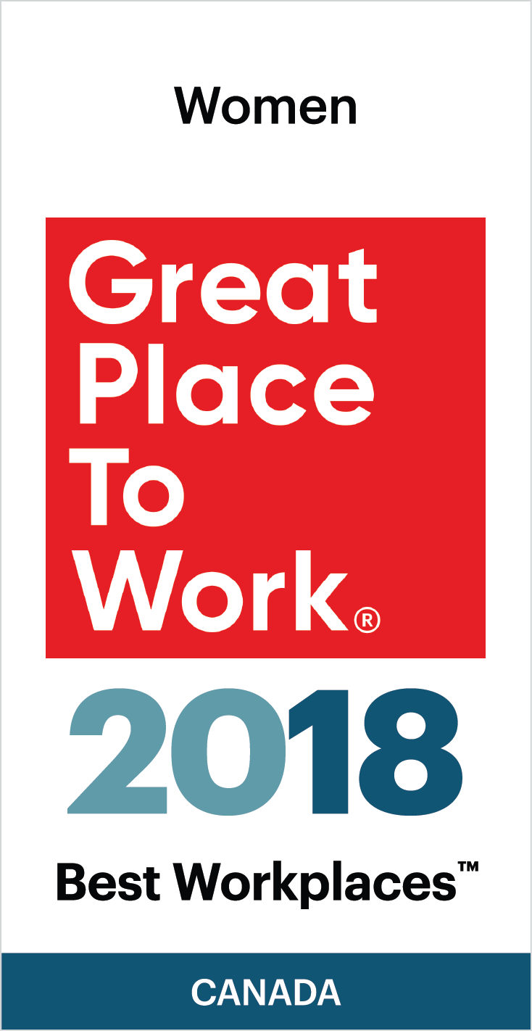
Your Company Name is proud to announce that our organization has been named to the 2018 LIST OF BEST WORKPLACES™ FOR WOMEN
Your Company Name received this honour after a thorough and independent analysis conducted by Great Place to Work®.
The list of the 50 Best Workplaces™ for Women is based on direct feedback from employees of the hundreds of organizations that were surveyed by Great Place to Work®. The data has a 90% confidence and a plus or minus 5% margin of error.
Analysis of the data to compile this list focused on the following considerations:
      - For eligibility, companies must be Great Place to Work™ certified in the past year.
      - Minimum 15 female employees in the organization
      - Minimum 90% positive response to the statement “I am treated fairly regardless of my gender”
      - GPTW determined the BEST based the overall Trust Index score of eligible organizations and their programs and practices that support and advance women.

Insert a paragraph about your organization’s commitment to being a great workplace culture] OR [Insert a motivational quotation from your CEO/President.
About your company:
[Your Company Description]
About Great Place to Work®:
Great Place to Work ® (GPTW) is the global authority on high-trust, high-performance workplace cultures. Through proprietary assessment tools, advisory services, and certification programs, GPTW recognizes the world's Best Workplaces in a series of national lists including those published by Fortune magazine (USA) and The Globe & Mail (Canada). Great Place to Work® provides the benchmarks, framework, and expertise needed to create, sustain, and recognize outstanding workplace cultures. www.greatplacetowork.ca and @GPTW_Canada

Media contacts:
[insert your company’s PR contact and coordinates]

